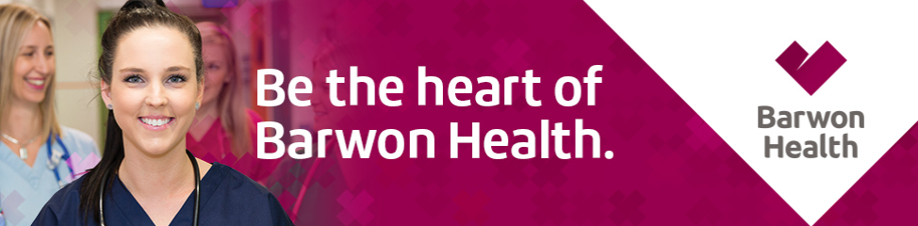
Medical Officer – General Diabetes
- Have the best of both worlds - Career and lifestyle in Geelong only minutes from our Surfcoast
- Ongoing experience and professional development in a supportive work environment
- Enhance your career at Victoria's leading regional health care service

About the facility
Barwon health is the major regional health provider for the Barwon South West region. It is Victoria’s largest regional health service with one of the busiest hospitals in the state, University Hospital. We serve over 500,000 people through the efforts of over 7,000 staff and more than 1000 volunteers. We provide care at all stages or life and circumstance through a wide range of services from emergency and acute to mental health, primary care, community services, aged care, and subacute/rehabilitation. Care is provided to the community through over 21 key locations throughout the region.

About the role
The Endocrinology VMO will provide Endocrinology Consulting Services at the University Hospital; Diabetes Referral Centre Clinics and, if required, at the Diabetes Outreach Clinics (DRC) at Newcomb and Anglesea Community Health Centre’s.

DRC service include Diabetes Foot Unit, Diabetes in Pregnancy, Early Review Clinic and General Diabetes as well as CGMS and CSII. Teaching Advanced Trainees and medical students is also an essential component of the role.

We strive for clinical excellence with a multidisciplinary team approach which includes Credentialed Diabetes Educators, Accredited Practising Dietitian and Podiatrist.

DRC is a tertiary Diabetes Centre, accredited by the National Association of Diabetes Centres.

About the culture
You will work with an innovative multidisciplinary team who maintain extensive knowledge and experience. You will have support and guidance from fellow team members and management who exhibit our Barwon Health values, respect, compassion, commitment, accountability and innovation.

Barwon Health staff benefits
- Flexible working arrangements
- Professional development
- Access to employee wellness facility
- Salary packaging
- Social club
- Centrally located at University Hospital, only minutes from the vibrant waterfront
- Our Commitment to Child Safety
- Be our future Barwon Health Strategic Plan
- Aboriginal Employment Plan

Reference #, 158736
Location, University Hospital Geelong
Key Contact, Professor Mark Kotowicz, (03) 4215 2881

Closing Date, 18th June 2019
For further information, please visit https://bit.ly/2Mgca9j or telephone the Key Contact Person listed above.

