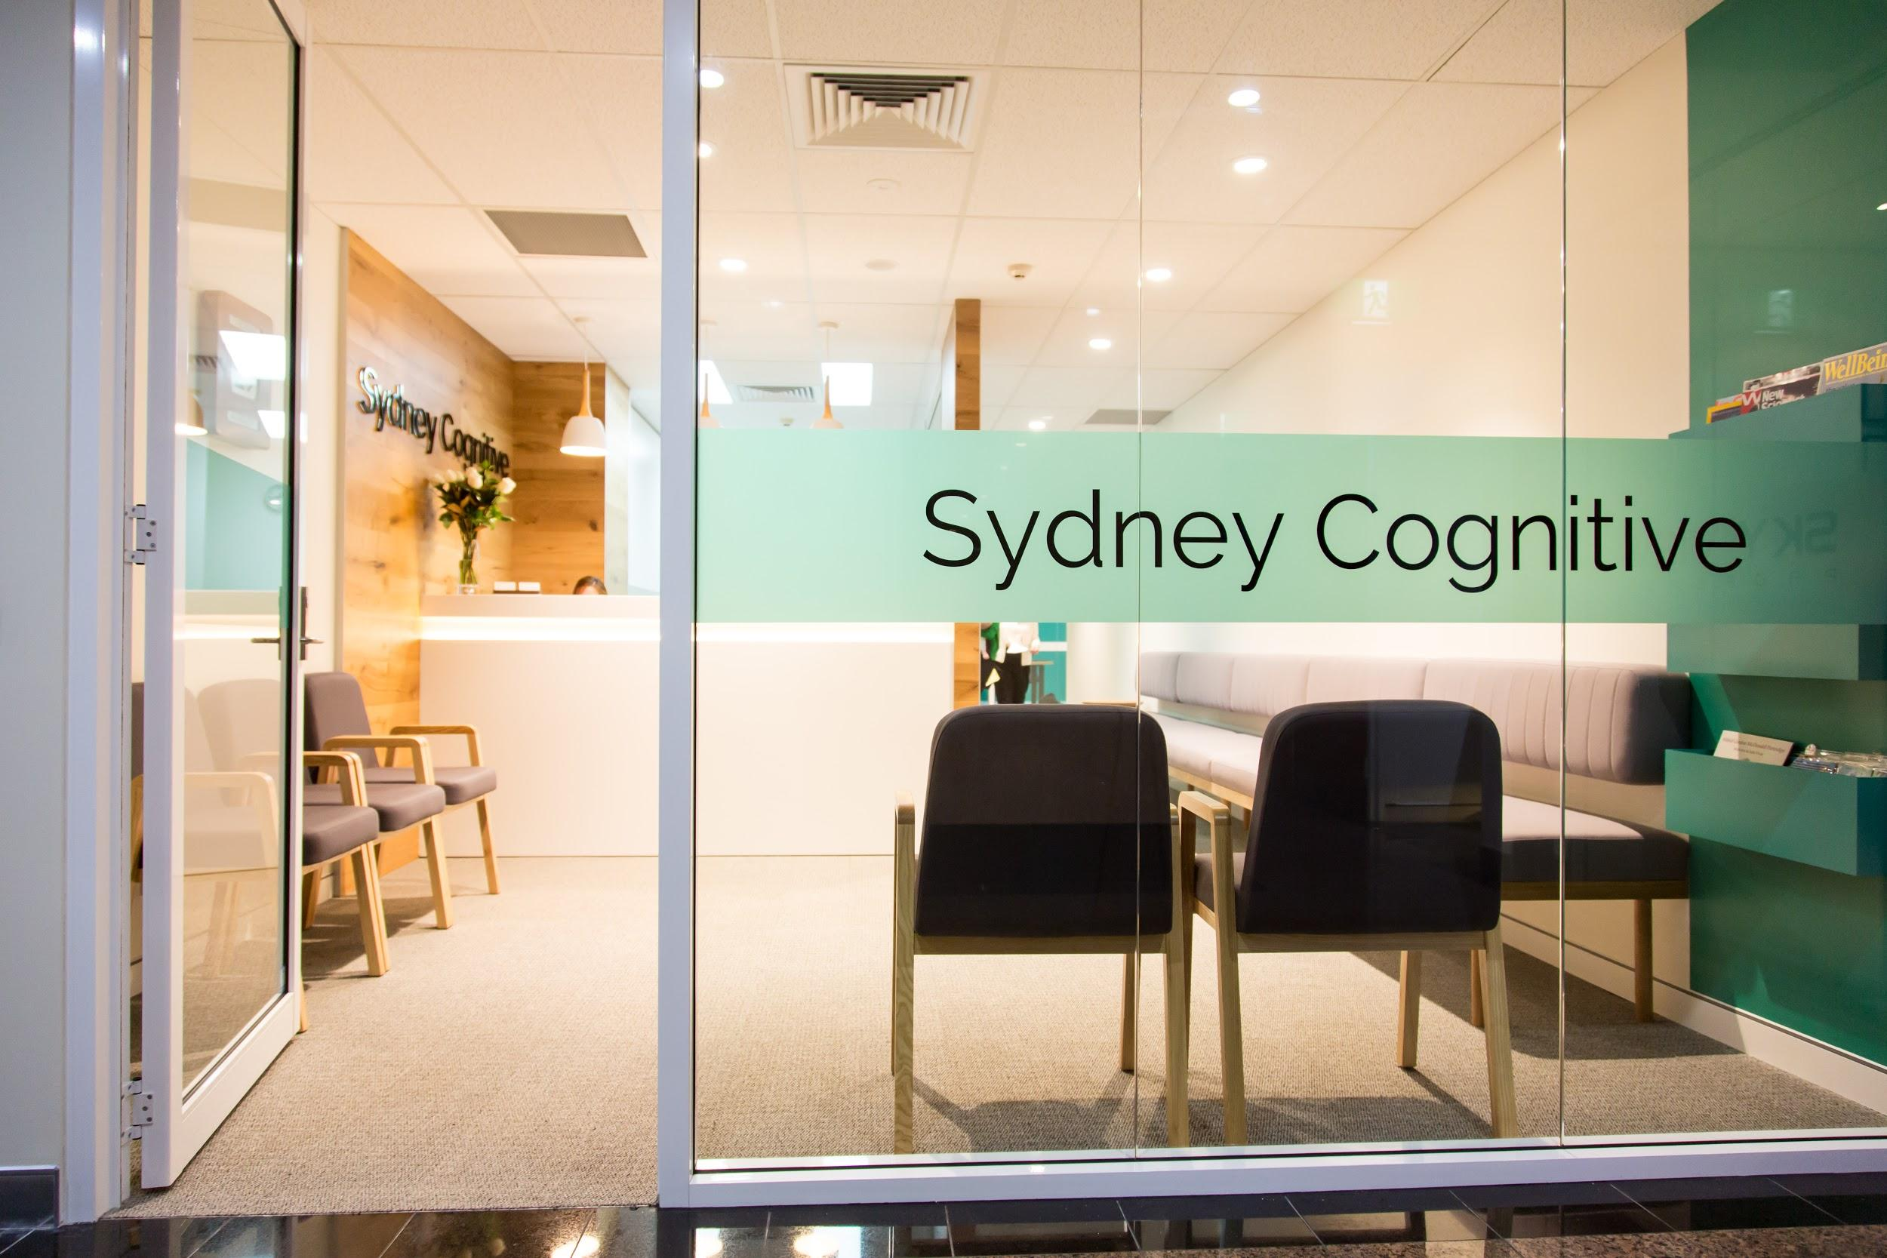
Consultant endocrinologist sought for private clinic

Endocrinologists are sought to commence private practice at Sydney Cognitive - a vibrant multidisciplinary practice in the heart of North Sydney.

The practice offers easy public transport options and disabled access facilities.

We have an existing dedicated team of several neurologists, a geriatrician, neuropsychologist, psychologist, neuro-occupational therapist and neurophysiology technicians who service basic neurophysiology.

We focus on the management of cognitive and neuropsychiatric disorders, including patients with younger-onset dementia, headache disorders, and encephalitis. We see all general neurological conditions including patients with neuropathy, brain malignancy, and neuroinflammatory disorders. Diabetes is a frequent comorbidity in our patients in addition to thyroid disease and pituitary lesions.

Our aim is to provide excellence in care, involvement in research and community advocacy.

Though we are an integrated service, we encourage maintenance of each specialist’s direction towards their own practice interests, with flexibility offered for timetables and billings. Expansion to include other practitioners such as a neurosurgery, pain medicine specialist, rheumatologist, speech pathologist, and residential care nurse is foreseen.

Patients
Sydney Cognitive is ideally placed to service the professional population of the North Sydney CBD as well as expanding residential and retirement populations in the area. It provides a subspecialist clinic for referrals across Sydney, Canberra and regional centres.

Facilities
The clinic is a newly built and spacious facility with 7 clinic rooms and a strong consideration towards the needs of our patients. The clinic design allows a clean and modern environment, conducive to a high throughput, and includes a meeting room, staff toilet facilities, and kitchenette. The meeting room also allows space for family meetings. The location in North Sydney gives access to trendy cafes and lunch spots. A hotel is nearby for country patients should they require overnight accommodation.

On-site secretarial support is provided Monday-Friday 8am-5pm and is inclusive of all stationary, postage, IT, internet and telephone use.

Contact
The clinic is available to be inspected on request and all enquiries may be directed to Ana or Clarissa on (02) 9900 5500 or reception@sydcog.com.au

