Endocrine Society of Australia
The Ken Wynne Post-Doctoral Research Award
Recipient: Assoc Prof Lisa Moran

Title: Assessment and treatment of the atherogenic lipid profile in Polycystic Ovary Syndrome
I am honoured to be awarded the ESA Ken Wynne Memorial Postdoctoral research award. My research focuses on women with polycystic ovary syndrome (PCOS). In this project I assessed approaches to prediction of risk factors for heart disease in PCOS. PCOS is a common condition affecting up to 1 in 5 women. It is associated with reproductive features including infertility, ovulatory problems and hyperandrogenism. It is also associated with a worsened risk profile for diabetes and heart disease with features including obesity, insulin resistance, glucose intolerance, dyslipidaemia, inflammation and an increased risk of diabetes and cardiovascular disease. The presentation of PCOS is heterogeneous.. Abnormal lipid levels are very common in women with PCOS and usually include elevated triglyceride levels and low high-density-lipoproteins cholesterol concentrations. Dyslipidaemia can also be assessed by examining the subclasses of LDL and HDL that differ in size, density, composition and atherogenicity and by assessing specific lipid classes and molecular species.

Study 1
Introduction: Previous research reported that women with PCOS have significant qualitative LDL alterations, with increased levels of atherogenic small, dense LDL. However there is limited research examining HDL subclasses in PCOS or examining how the LDL and HDL subclasses vary across the different presentations of PCOS.
Methods: We examined the LDL and HDL subclass distribution by gel electrophoresis in seventy four women (49 with PCOS and 25 without PCOS).
Results: In comparison to women without PCOS, women with PCOS had significantly higher body weight (p=0.004), waist circumference (p=0.001), body mass index (p=0.001), insulin (p=0.029), C-reactive protein (p=0.002), HOMA (p=0.046) and asymmetric dimethylarginine (p=0.019), while plasma lipids did not differ significantly. Regarding HDL subclass distribution, PCOS had decreased HDL2b (49.1±8.3 vs 53.4±8.1, p=0.041) and increased HDL3a particles (14.8±3.4 vs 12.5±3.4, p=0.005). In addition, HDL2b particles correlated negatively with triglycerides (r=-0.367, p=0.01), and positively with HDL-C (r=0.566, p=0.01), while HDL3a particles correlated negatively with HDL-C (r=-0.503, p=0.01).
Conclusion: Women with PCOS have decreased larger and increased smaller HDL particles compared to women without PCOS. This indicates a more atherogenic lipid profile even when there are no differences in the classic lipid profile.

Figure 1: Differences in HDL subclasses in women with and without PCOS
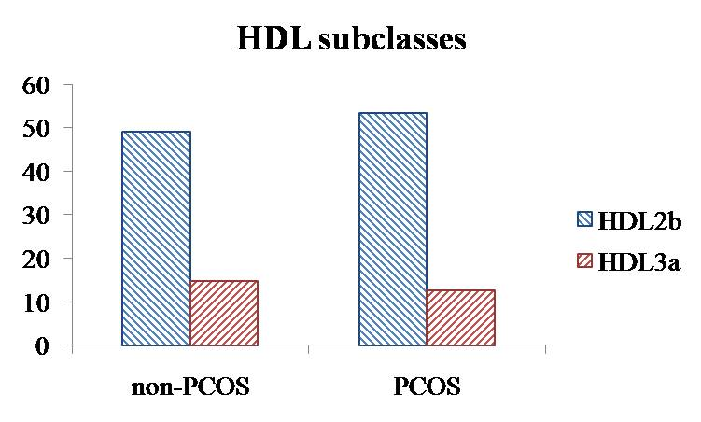

Study 2
Introduction: Lipid species can also be classified by lipidomics using liquid chromatography massspectrometry (LCMS). This identifies specific molecular species across lipid classes and subclasses with important implications for lipid profiling for disease classification, risk assessment and lipid metabolism associated with specific disease states. While lipidomics has been previously used for the classification of lipid biomarkers in disease states including obesity, hypertension and type 2 diabetes, it has not been performed in PCOS.
Methods: In biobanked samples, we examined the lipidomic profile in 156 women (92 with PCOS and 64 without PCOS), specifically 24 lipid classes comprising 325 species.
Results: Women with PCOS had significantly higher weight (p=0.024), BMI (p=0.004), insulin (p=0.006), HOMA (p=0.016), testosterone (p<0.001), FAI (p<0.001), triglycerides (p<0.001) and CRP (p<0.001) but no differences in waist circumference (p=0.212), fasting glucose (p=0.945), total cholesterol (p=0.059), HDL (p=0.750), LDL (p=0.217) or DBP (p=0.175). There were no differences in lipid classes or species between women with or without PCOS. There were no association of lipid classes with total testosterone on unadjusted or adjusted models. There was a significant negative association of SHBG with diacylglycerol and triacylglyercol on adjusted models. There was a significant positive association of FAI with ceramide, phosphatidylcholine, lysophosphatidylcholine, phosphatidylethanolamine, lysophosphatidylethanolamine, phosphatidylinositol, diacylglycerol and triacylglyercol on adjusted models.
Conclusion: While PCOS status was not associated with differences in lipid classes or species, SHBG and FAI (as key pathophysiological aspects of hyperandrogenism in PCOS) were associated with differences in a number of lipid classes, some of which have been previously shown to be different in conditions such as impaired glucose tolerance and type 2 diabetes.

Future implications
We initially aimed to examine changes in the atherogenic lipid profile with different interventions in PCOS. However, as we had the opportunity to examine the profile with two different techniques (gel electrophoresis and LCMS) we focused this initial work on comprehensively determining the differences in these techniques across two large cohorts of women with and without PCOS. A future program of work has now been identified following on from this work which will involve:
Study 1: Systematic review examining differences in lipid classes/species with different pharmacological and lifestyle treatments in the general population.
Study 2: Systematic review examining differences in lipid classes/species across different obesity or cardiometabolic related conditions for use in determining which intervention approach identified in project 1, may be most appropriate for specific diseases and conditions.
Study 3: Development of risk prediction algorithms for screening for cardiometabolic dysfunction in women with PCOS from our datasets in project 1 and 2.
Study 4: Cross-sectional trial validating the algorithms developed in study 3 in a new population of women with and without PCOS.

Conclusion
We observed differences in HDL subclasses in women with and without PCOS and showed significant associations of lipid classes with SHBG and FAI. This may have important implications for exploring the metabolic consequences of hyperandrogenism in PCOS for potential future identification of women with PCOS at the highest metabolic risk.

Progress report
1: All samples analysed
2: Statistical analysis completed
3: Two manuscripts in final stage of drafting and to be submitted by August 2016

